In this project I have tried to demonstrate the use of python in businesses for profit enhancement.

Unsupervised Learning(Clustering) is used to find the hidden data patterns or structures which can be used by an organiztion(like mall, shopping complexes etc) to target the right audience and hence increase profit margin.

Also, this approach allows the organizations to spend less on advertisements by first choosing the right audience and then advertising.

[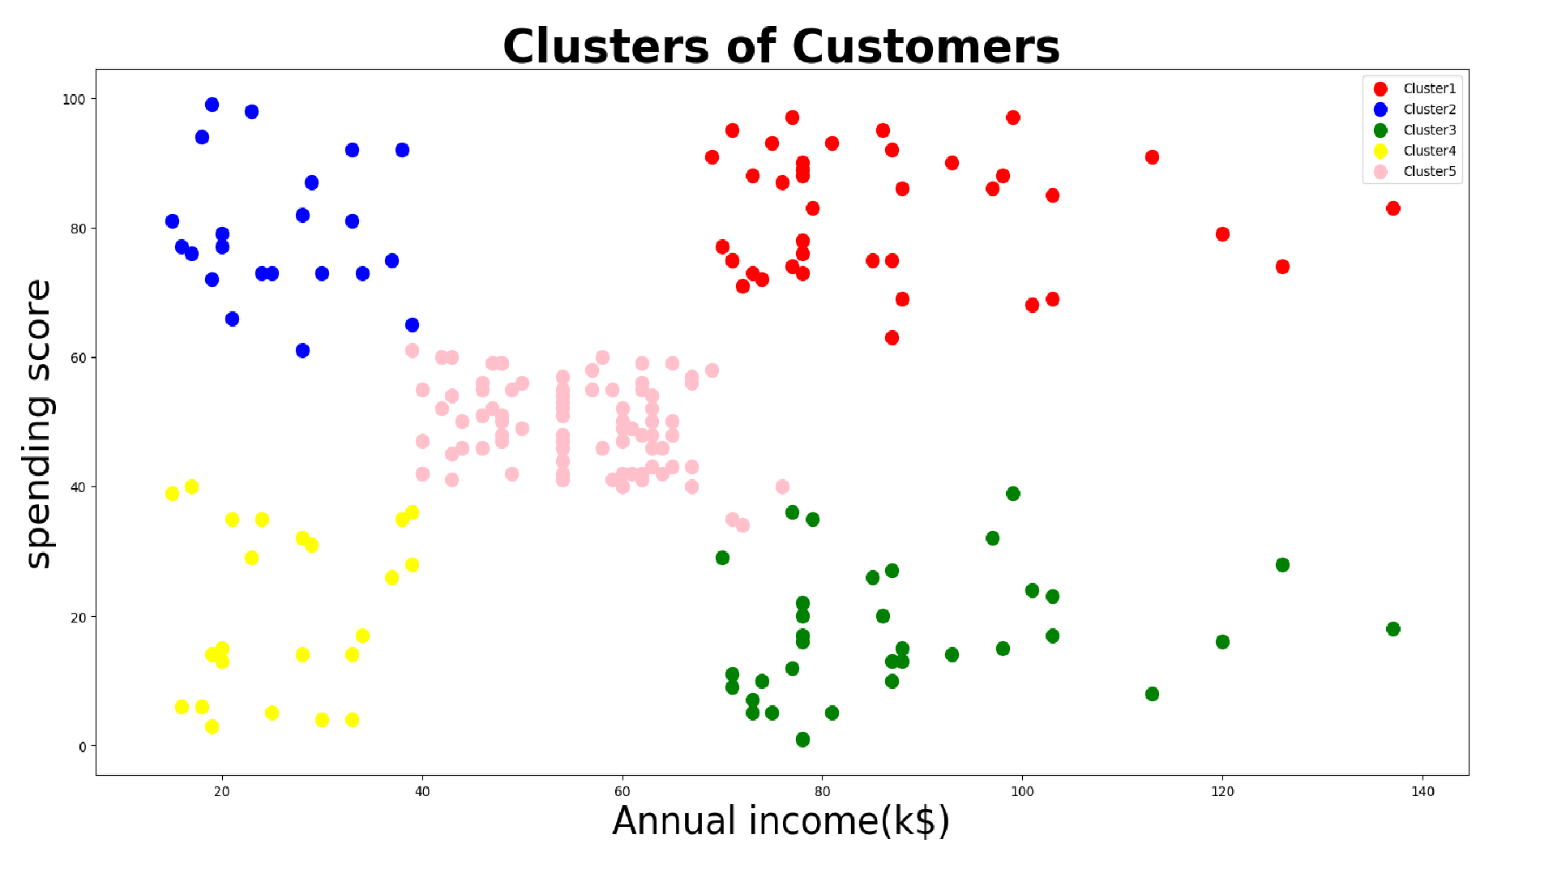](https://github.com/ShubhankarRawat/Mall-Customers-Segmentation/blob/master/mc%20-%205.png)

The dataset used has following details : The features in the dataset are explained below :

1. Customer ID - It is the unique ID assigned to the customer
2. Gender - Gender of the customer
3. Age - Age of the customer(in years)
4. Annual Income(k$) - Annual income of the customer in k$
5. Spending Score - Score assigned to the customer by the mall/shopping complex based on the customer spending nature and behaviour